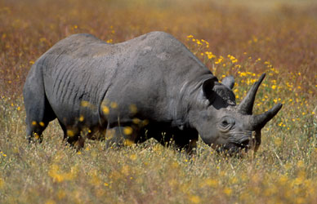 [39 rhinos killed in 10 months in Kaziranga National Park](http://timesofindia.indiatimes.com/home/environment/flora-fauna/39-rhinos-killed-in-10-months-in-Kaziranga-National-Park/articleshow/16680357.cms)

PTI | 11 hrs ago | The death of 39 rhinos in and around the world-famous Kaziranga National Park in less than 10 months has brought to the fore the threat faced by the endangered animal.